Overview
The ProjectWise Gateway Service is used to enable external ProjectWise Explorer clients (individuals located outside the company’s firewall including consultants and MnDOT employees) to reach a ProjectWise Integration Server residing on the secure local network inside the MnDOT firewall.

Notes:
- Communication is through port 5800, so ensure that your firewall has this port open.
- For credentials to ProjectWise at MnDOT, contact your MnDOT project Manager.

Licensing
ProjectWise licensing will be the responsibility of the consultants using the ProjectWise Gateway. If they already have a license for ProjectWise, it will be used. Otherwise, they can be purchased or leased by contacting Bentley. Please review this web site for licensing (passport subscription) http://www.bentley.com/en-US/Subscriptions/Bentley%20Passport/

Setup
- Install ProjectWise Explorer Select Series 2 or 3 (SS2 or SS3).
- Open the Control Panel > ProjectWise V8i Network.
- Click on the DNS Services Tab and set as shown here.
  - Name: Any name
  - Hostname: pwweb.dot.state.mn.us
  - Port: 5800
  - Check “Prevent UDP”.
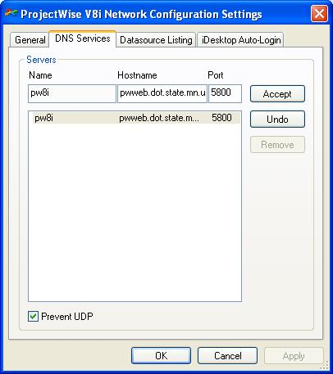
- Click Add.
- Click the Datasource Listing tab and repeat steps 3 & 4.
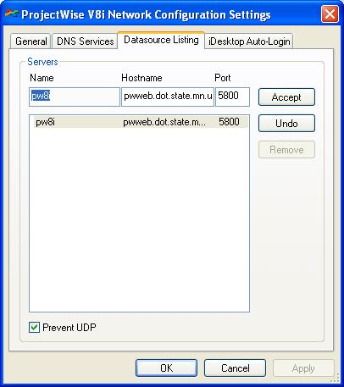
- Click OK.
- Launch ProjectWise Explorer and you should see the two MnDOT datasources.
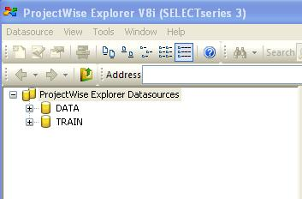
- Login to the “DATA” datasource with the credentials provided by your MnDOT project manager to see project data.

